Process Book

**Project Title:** COVIDStat Visualizer - Interactive COVID-19 Insights for EU/EEA

**Names, UIDs, and e-mails:**

* Hima Mynampaty, u1528521, [u1528521@utah.edu](mailto:u1528521@utah.edu)
* Praneeth Chavva: u1465506, [u1465506@utah.edu](mailto:u1465506@utah.edu)
* Hemasundar Tatipudi: u1465343, [u1465343@utah.edu](mailto:u1465343@utah.edu)

[GitHub Repository Link](https://github.com/dataviscourse2024/group-project-covidstat-visualizer)

**Background and Motivation**

The COVID-19 pandemic has significantly impacted all regions of the world, and understanding the differences in outcomes across countries can provide valuable insights for policy decisions and future health crises. We chose to concentrate on the European Union (EU) and the European Economic Area (EEA) due to the region's diverse pandemic responses, which includes a variety of lockdown measures, vaccination strategies, and testing protocols. This project combines our interests in public health, data visualization, and interactive technologies to create a valuable tool for analyzing COVID-19 trends in these regions. Furthermore, we are motivated by the tool's ability to inform policymakers and health professionals about the efficacy of interventions in mitigating the virus's impact.

**Project Objectives**

Our primary goal is to develop an interactive dashboard that provides insightful and easily accessible COVID-19 data visualizations for the EU/EEA region.

The main questions we want to answer with this visualization are:

* How have COVID-19 cases and death rates varied over time in different EU/EEA countries?
* What effect did vaccination campaigns have on reducing cases and deaths in the region?
* How do testing and positivity rates correlate with case and death trends in various countries?
* Which countries responded most effectively, and what factors contributed to their success (e.g., vaccination rates, testing strategies, and government responses)?
* How did the pandemic's waves (e.g., first wave, post-vaccine era) differ regarding case surges and control strategies?

**What We Aim to Learn and Accomplish**

We want to get a better understanding of the dynamics of the COVID-19 pandemic in the EU/EEA region by

* Graphing trends in cases, deaths, vaccinations, and testing rates across countries.
* We are comparing the results of different public health interventions and vaccination campaigns.
* Identifying patterns in pandemic progression and highlighting effective mitigation strategies.

**Benefits:**

1. **Inform Policy and Research:** Provide clear, data-driven insights that will help policymakers and researchers understand the effectiveness of various response measures.
2. **Public Awareness:** Help the public visualize the pandemic's impact in their own and neighboring countries, fostering a better understanding of global health dynamics.
3. **Decision-Making:** Provide actionable insights for future pandemic preparedness by emphasizing the links between vaccination efforts, testing rates, and case reductions.
4. **Comparative Insights:** Allow users to compare countries and identify best practices that resulted in lower case and death rates, potentially informing future strategies.

By answering these questions and meeting our goals, we will create a tool that improves understanding of the pandemic's impact in the EU/EEA and facilitates better decision-making for public health responses.

**Data**

We will collect data from a publicly available source called the European Centre for Disease Prevention and Control (ECDC) for detailed EU/EEA statistics.

**Data Sources**

* [Data on 14-day notification rate of new COVID-19 cases and deaths](https://www.ecdc.europa.eu/en/publications-data/data-national-14-day-notification-rate-covid-19)
* [Data on COVID-19 vaccination in the EU/EEA](https://www.ecdc.europa.eu/en/publications-data/data-covid-19-vaccination-eu-eea)
* [Data on testing for COVID-19 by week and country](https://www.ecdc.europa.eu/en/publications-data/covid-19-testing)
* [Data on country response measures to COVID-19](https://www.ecdc.europa.eu/en/publications-data/download-data-response-measures-covid-19)

**Data Processing**

We anticipate extensive data cleanup to ensure the datasets are accurate, complete, and ready for visualization.

The main tasks for data processing are:

1. **Filter by region (EU/EEA):** Because the project is specifically focused on the EU/EEA region, we will filter the data to include only countries from that region. Non-EU/EEA countries will be removed from the datasets to ensure that we are working with accurate geographic data.
2. **Handling Missing Data**: Several columns, including "tests_done," "positivity_rate," and "vaccination rates," contain missing or incomplete entries. We will close these gaps by either imputing missing values using statistical methods (for example, forward or backward filling based on trends) or filtering out incomplete records.
3. **Standardizing Date Formats:** The datasets include time-based fields (e.g., "year_week," "date_start") that must be standardized for consistent time-series analysis. We will convert these fields to a standard date format to facilitate filtering and visualization.
4. **Aggregating Data:** To calculate summary statistics, we will aggregate data by country and over specific time periods (e.g., weekly or monthly). Total cases and fatalities by country. Vaccination rates vary by population segment and country. Testing and positivity rates vary over time. Cumulative data (e.g., total cases, deaths, and vaccinations per capita).
5. **Merging Datasets:** To ensure that all relevant data is available in a single view, we will combine datasets using common fields such as country, country code, and time period (e.g., year_week). This will enable us to visualize multiple metrics (cases, deaths, vaccinations, and testing) simultaneously.

Quantities to Derive:

* **14-day case and death rates per 100,000 population** for easier country-to-country comparisons.
* **Vaccination coverage rates** by age group and risk category.
* **Testing and positivity rates** for evaluating testing effectiveness.
* **Case-to-vaccination correlation metrics**, showing how vaccination efforts correlate with the reduction in case counts and deaths.

### **Implementation:**

We will use Python for data processing, utilizing libraries like Pandas for data manipulation, merging, and cleaning. The workflow will include:

* Loading datasets into data frames.
* Cleaning and imputing missing values using methods such as forward fill, backward fill, or mean imputation.
* Aggregating and transforming data to calculate derived metrics like case rates, death rates, and vaccination percentages.
* Merging the datasets on common keys to create a unified dataset for visualization.

### **Visualization Design:**

We used the Five Design Sheet Methodology to discuss, design, and weigh advantages and disadvantages to come up with a final realization.

**Brainstorm:** Our aim from the beginning is to visualize COVID-19 data in an interactive and useful way. The main conflict was to decide on which region to focus on. We considered doing it for the whole world, India and the EU/EEA region. We concluded on EU/EEA due to different positives mentioned in our Ideation sheet below.

The discussion continued to decide on which data sets were available and which data sets to use. Later we came up with very rough sketches on how we could represent the data from the data sets. As there were many ideas, we focused on filtering the data sets, categorizing the data, coming up with designs to represent the data chosen and finally combining them all in a refined way.

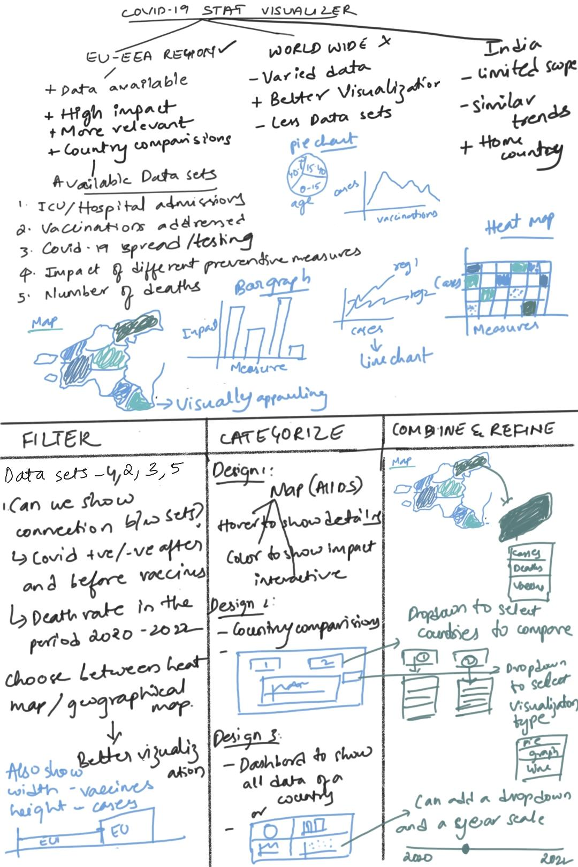

**Design 1:** As we had multiple ideas and things to represent in the web application, we have decided to do 3 screens of visualizations.

Page1 is our main screen with an EU/EEA region map with sequential color pallet, where colors represent the mortality rate (number of deaths in relation to number of positive cases after normalizing). Page2 is a screen used to compare derived data from the data sets available between different states. Page 3 is a dashboard with all data at a single place of a particular state.

We have discussed how our screens would look, what are our major focus areas, what are the features available for users, advantages and disadvantages of all three screens.

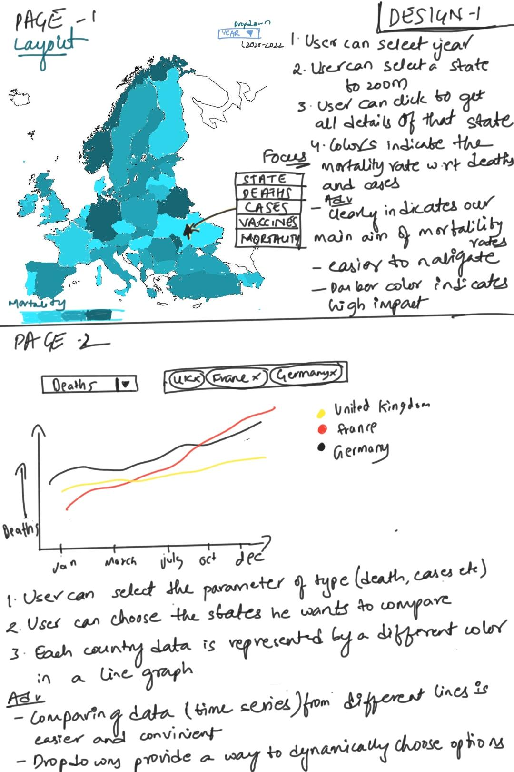

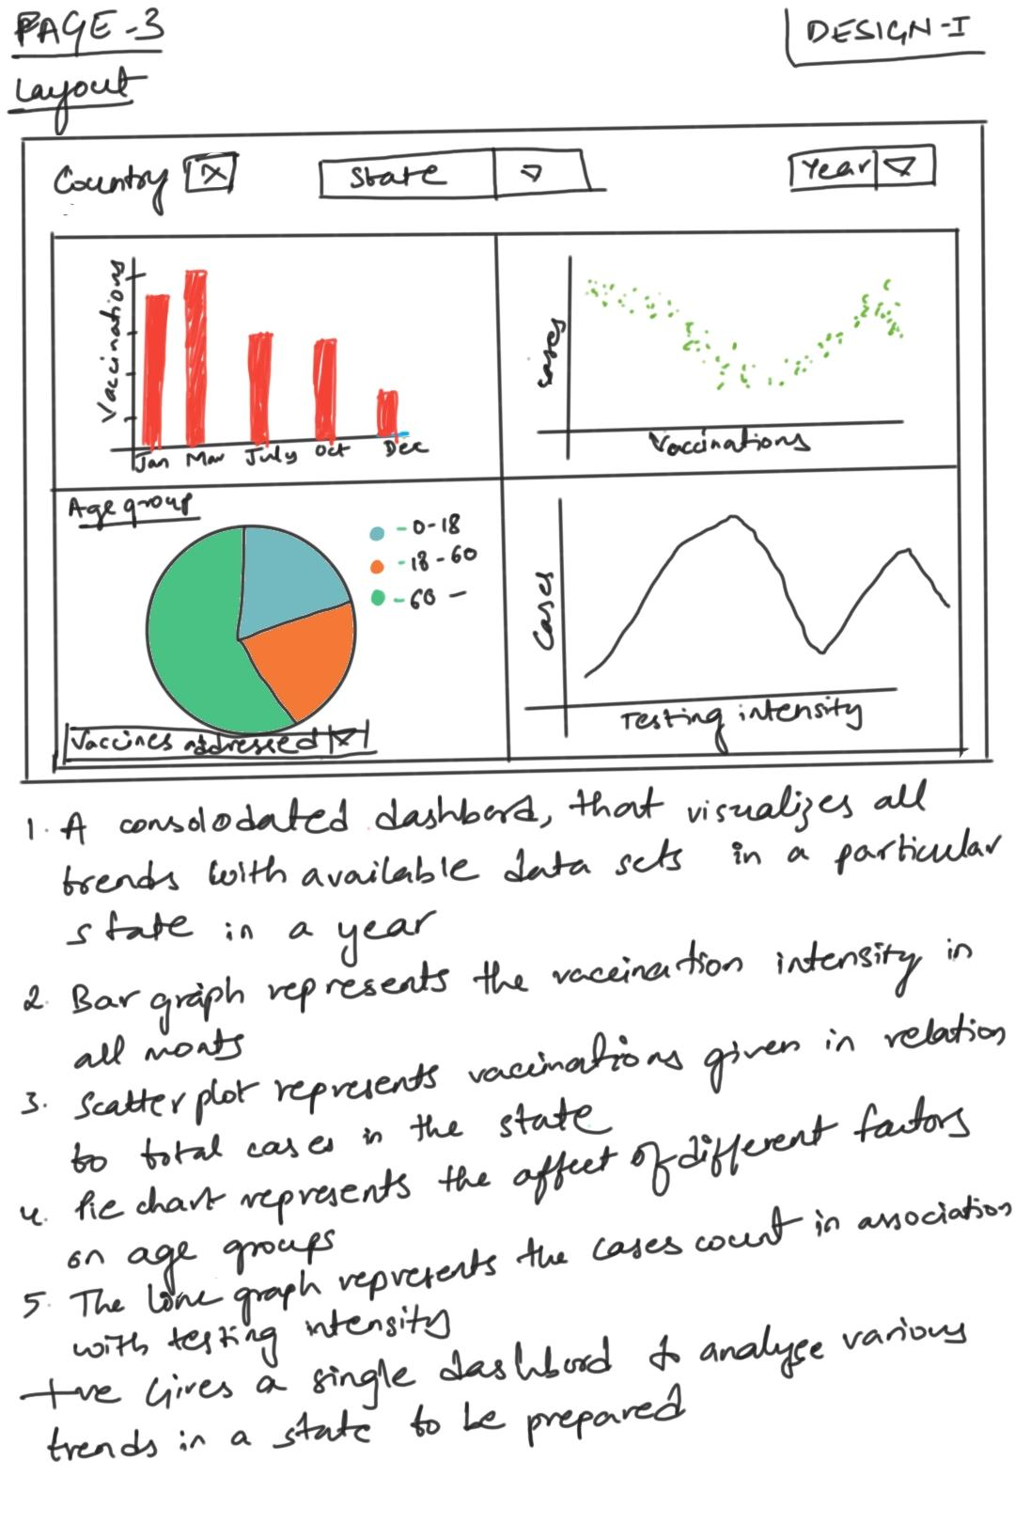

**Design2:** We thought of different ways we could represent the main screen. One of the main competitors to the map was the bar graph below as it would allow us to show three features of the data(cases, mortality and vaccinations) as the main focus, without having to hover/click on the bars.

But the design had its own disadvantages which are discussed in the sheet.

**Design3:** Instead of representing in a single line graph, initially we had an idea of comparing only two states using two dropdowns to select the state and two different graphs representing two different metrics.

But the main flaw is the constraint of having to select only two states. Other points are weighed as well.

**Realization:** We debated on which designs to incorporate and concluded on using the ones that best fit a user’s requirement and ease of navigating the visualization.

The key data are being used, navigations and selections that a user can perform, advantages of this visualization, time range of our visualization are discussed, and we came to a conclusion!

### **Must Have Features:**

**Interactive Dashboard**

* EU/EEA Overview Map: An interactive map highlighting COVID-19 statistics by country with choropleth visualization.
* Country Filters: Options to select and filter country for specific visualizations.
* Time Frame Filters: Controls to filter data by specific time periods (e.g., pre-vaccination, post-vaccination or based on a specific wave) and/or years.
* Key Metrics Visualization: Use of charts and plots to display trends in cases, deaths, testing, and vaccination rates.
* Tooltips and Pop-ups: Hover-over tooltips and pop-up windows providing detailed information for selected data points.

**Comparative Analysis**

* Country Comparison Charts: Line and bar charts comparing COVID-19 trends and responses between two countries.
* Case-to-Vaccination Correlation Metrics: Visualization of the correlation between vaccination rates and case reductions.

**Visualization for Vaccination**

* Vaccination Coverage Charts: Pie charts and bar graphs displaying vaccination coverage rates by age group and risk category.
* Vaccination Impact Analysis: Scatter plots showing the relationship between vaccination coverage and case/death rates, with trendlines for correlation analysis.

**Optional Features**

**Advanced Filtering**

* Custom Date Ranges: Users can define custom date ranges for more specific time frame analyses.
* Data Download Option: Ability for users to download raw data or visualizations for offline analysis.

**Comparing Past Data**

* Pandemic Waves Visualization: Detailed comparisons of different pandemic waves and their impact on cases, deaths, and responses.

**Predictive Analytics**

* Trend Forecasting: Implementation of predictive models to forecast future trends based on historical data.
* Scenario Analysis: Visualization of potential future scenarios based on different vaccination and testing strategies.

**User Customization**

* Customizable Dashboards: Allow users to customize their dashboard view by selecting which metrics to display and how to arrange them.
* Saved Views: Feature for users to save and revisit their preferred dashboard configurations.

**Project Schedule**

Week 1 (Sept 13)

* **Announce the Project**: Decide and announce the project.\
* **Project Proposal**: Begin the process book by outlining the background, goals, and schedule.
* Finalize project requirements and objectives.

Week 2 (Sept 20)

* Verify data from the European Centre for Disease Prevention and Control (ECDC).
* Set up the project repository and initial environment.
* Start data cleaning and preprocessing.
* **Project Review**: Discuss the project with the instructor, get feedback, and explore potential improvements or ideas.

Week 3 (Sept 27)\

* Handle missing data and standardize date formats.
* Filter non-EU/EEA countries from the datasets.
* Handle inconsistent data and perform necessary data aggregations.

Week 4 (Oct 4)

* Merge datasets by country and time period.
* Complete feature engineering for derived features.
* Validate the prepared data and check for any inconsistencies.
* Perform exploratory analysis to summarize statistical data and generate simple plots.

Week 5 (Oct 11)

* Build prototypes for charts and plots to be used in the visualizations.
* Develop a choropleth map with EU/EEA country-level stats.

Week 6 (Oct 18)

* Add additional functionalities and filters to enhance comparisons and visualizations.
* Optimize data handling to ensure smooth dashboard performance.

Week 7 (Oct 25)

* Complete the visualization dashboards, including all required charts and plots.
* Consider adding any optional features to enhance the dashboards.
* **Project Milestone**: Submit the code, process book, and prototype of the working visualizations.

Week 8 (Nov 1)

* Test and debug visualizations on different screen sizes and with various data types.
* Improve interactivity with tooltips and hover transitions.
* **Peer Feedback**: Gather feedback from peers to identify areas for improvement.

Week 9 (Nov 8)

* Refine the visualizations and user interface based on feedback.
* Perform thorough testing for bugs and performance issues.

Week 10 (Nov 15)

* Develop optional features to make the dashboard more informative.

Week 11 (Nov 22)

* Finalize documentation and create user guides for navigating the project.
* **Project Screencast Submission**: Submit a screencast video showcasing the project.

Week 12 (Nov 29)

* Prepare the dashboard for deployment.
* Complete the final process book.
* Review the project internally to ensure all areas of project are thorough.

Week 13 (Dec 6)

* Validate the final code, data, process book, and README file for the GitHub repository.
* Create a final release on GitHub repository and upload the screencast video.
* **Final Project Submission**: Hand-in the final project.

**Team responsibilities**

* Hima Mynampaty: Line charts, comparative analysis, and scatter plots.
* Praneeth Chavva: Data processing, map-based visualization development.
* Hemasundar Tatipudi: Dashboard integration, filters, and interactivity.

**FEEDBACK ON INITIAL PROPOSAL FROM MEETING WITH TA PROMA**

(review meeting on 09.19.2024, entry by Praneeth Chavva)

On 09.19.2024, we met with TA Proma regarding our initial project proposal for the "COVIDStat Visualizer." Below are the key points and takeaways from the discussion:

1. Project Focus: Proma advised us to refine the project’s primary focus. Instead of addressing several aspects (case rates, death rates, vaccination campaigns, and positivity rates), we should focus on one key aspect. For example, we might concentrate on how vaccination efforts influenced case and death rates across EU/EEA countries.
2. Simplicity and Storytelling: Proma emphasized that visualizations should tell a story. Rather than overwhelming users with multiple data points, the project should guide users through a logical flow—starting with foundational metrics and progressing toward key insights. This approach will help users better understand the data and its implications.
3. Visualization Refinement: It was suggested that we reduce the number of visualizations and focus on those most critical to telling the story. An interactive map showing vaccination rates and a line chart illustrating case trends over time could suffice to present the data effectively.
4. Next Steps: We must revise the proposal to reflect this simplified approach and create a prototype that aligns with the storytelling method. Our next meeting will involve reviewing these adjustments.
5. Upcoming Deadlines: Prioritize data cleaning and developing the initial visualizations, ensuring they follow a narrative structure. Revised visualizations and mockups should be ready for the following review.

**Updated Project Plan**

Following TA Proma’s feedback, we've refined the project to emphasize a clear, story-driven approach. This updated plan narrows the focus to key aspects of COVID-19 waves and government interventions across EU/EEA countries, using four main visualizations to guide users through a cohesive narrative with a polished, user-friendly design.

**Project Scope & Direction**

Our goal remains the same: to explore the impact of government interventions on COVID-19 cases throughout the pandemic. To ensure clarity, we’ll focus on distinct pandemic phases and the effectiveness of responses, structuring visualizations to show the progression through each wave. Users will gain insights into how interventions influenced the spread and severity of COVID-19.

**Visualization Design and Ideas**

The design concepts from the original proposal remain intact. We continue to use interactive elements like timelines, bar charts, and line graphs to show trends and intervention impacts, but these are now organized with a clearer focus to enhance narrative flow.

1. First Wave vs. Post-Vaccine Era (Line Graph)

* Objective: Show contrasting trends in cases and deaths between the pre- vaccination and the post-vaccine era.
* Design:
  + Separate line graphs for cases and deaths with each graph containing two lines, color-coded to differentiate pandemic phases.
  + An X-axis timeline and a Y-axis for case/death counts.
* Interaction: Users can select countries and view tooltips on hover, providing context for case/death counts by date.

2. Timeline of Government Interventions and Case Peaks

* Objective: Illustrate the timing of interventions and how they align with case peaks.
* Design:
  + An X-axis for the timeline throughout the covid era
  + Y-axis displaying COVID-19 cases, allowing peaks to stand out visually.
  + Visual distinctions for intervention types, such as shapes or colors (e.g., "BanOnAllEvents" vs. "ClosDaycare").
* Interaction: Country selection and hover tooltips to show start and end dates, intervention type, and cases during intervention periods.

3. Comparing Case Reductions Between Waves (Bar Chart)

* Objective: Highlight the impact of the intervention by comparing case reductions across pandemic waves.
* Design:
  + Each country's bars are grouped by pandemic waves (e.g., First Wave, Second Wave), showing reductions visually.
  + A consistent color scheme across waves is used to enhance comparability.
* Interaction: Country filter and clickable bars to reveal detailed breakdowns of case reductions and interventions.

4. Government Response Stringency vs. Case/Death Trends (Line and Bar Graph)

* Objective: Correlate government response stringency with COVID-19 case/death trends.
* Design
  + Dual Y-axes: one for response stringency (as a line) and another for case/death counts (as bars), sharing a time-based X-axis.
  + Overlay design to make comparisons visually straightforward.
* Interaction: Users can hover to view stringency scores, cases, and death counts by time point, with country selection to see national trends.

**Alignment with the Original Proposal**

This updated plan preserves our original objectives while following TA Proma’s guidance for a focused, user-friendly approach. Although the overall focus is now more streamlined, the core design concepts—interactive maps, timelines, bar charts, and line graphs—remain consistent with our initial proposal. We maintain the intended depth of analysis by keeping these original design ideas, now presented with a clearer, narrative-driven structure. This will allow us to deliver a meaningful, cohesive perspective on COVID-19 waves and responses across EU/EEA countries while enhancing accessibility and insight for users.

**Data Preprocessing:**

To support this refined narrative, we’ve conducted extensive preprocessing to ensure data consistency, usability, and relevance for the visualizations.

**Cases and Deaths Dataset**

* Handling Missing Values: Forward-filled missing values in key columns (`rate_14_day`, `weekly_count`, `cumulative_count`) to maintain continuity.
* Date Conversion: Converted `year_week` to a proper datetime format (assuming Monday as the start of the week).
* Data Integrity Check: Added checks on cumulative cases and corrected any inconsistencies to ensure data accuracy.
* Pandemic Wave Categorization: Segmented data into different pandemic waves for a more structured analysis.
* Population Normalization: Created a `cases_per_million` metric to normalize case numbers by each country’s population.
* Time Aggregation: Included monthly and quarterly aggregations to support both granular and broader analyses.
* Data Cleaning: Removed unnecessary columns, retaining only those relevant to our visualizations.
* Sorting: Sorted the data by country and date to ensure consistent chronological order.

**Response Graph Dataset**

* Country Filtering: Filtered the dataset to include only EU/EEA countries, based on a predefined list.
* Date Conversion: Converted `date_start` and `date_end` into a proper datetime format for time-based analysis.
* Handling Missing `date_end` Values: Filled any missing `date_end` values with the latest available date for continuity.
* Stringency Score Calculation: Added a `stringency_score` to quantify intervention severity, assigning weights between 0 and 1 based on intervention type, with a default weight of 0.2 for unspecified interventions.
* Stringency Score Normalization: Scaled `stringency_score` to a range of 0-100 for consistency across interventions.
* Intervention Duration Calculation: Calculated `intervention_duration` as the number of days between `date_start` and `date_end`.
* Intervention Category Assignment: Classified interventions into broad categories (e.g., `Lockdown`, `Masks`, `Gathering`), assigning "Other" for unspecified interventions.
* Aggregated Stringency Data: Created an aggregated dataset with daily stringency scores by summing scores for each country and date.
* Categorizing Intervention Severity: Divided the stringency scores into severity levels (e.g., Low, Medium, High) for a simplified overview.

**Testing Dataset**

* Handling Missing Values: Applied forward fill and interpolation for `tests_done` and `positivity_rate`.
* Date Conversion: Converted `year_week` into a date format (assuming Monday as the start of the week).
* Testing Effectiveness Metric: Calculated `testing_effectiveness` as the percentage of `new_cases` relative to `tests_done`.
* Testing Effectiveness Categorization: Classified `testing_effectiveness` into 'High', 'Medium', and 'Low' using predefined thresholds.
* Rolling Averages: Added 7-day rolling averages for `tests_done` and `positivity_rate` to support smoother time series visualization.
* Data Cleaning: Removed unnecessary columns (e.g., `country_code`, `level`, `region`).
* Sorting: Sorted by `country` and `date` to ensure chronological consistency.

**Vaccination Dataset**

* Date Conversion: Converted `YearWeekISO` to a date format for chronological analysis.
* Sorting: Sorted by `ReportingCountry` and date to support cumulative calculations.
* Cumulative Vaccination Calculation**: Calculated cumulative vaccinations and created a `CumulativeVaccinationRate` as a population percentage.
* Vaccination Rate (Weekly): Added `VaccinationRateWeekly` to show weekly dose administration.
* Rolling Averages: Added a 7-day rolling average (`VaccinationRate_7d_avg`) for smoother trend visualization.
* Vaccination Milestones: Categorized countries based on vaccination milestones: <25%, 25%+, 50%+, and 75%+ vaccinated.
* Cumulative Validation: Recalculated cumulative doses for consistency, adding a `CumulativeCheck` column for validation.
* Data Cleaning: Dropped unused columns, focusing only on those relevant for visualization.

Additionally, we may need to perform some data processing to enhance the clarity and precision of the visualizations.

**Progress on Visualization Prototypes for "Pandemic Waves and Government Responses**

With our data preprocessing completed, we have begun developing and refining visualization prototypes that form the core of our analysis on COVID-19 trends and government responses. These prototypes use sample subsets of our data, providing initial layouts and basic interactivity. This approach ensures we are on the right track while allowing us to gather feedback and refine before adding advanced features.

**Completed Visualizations**

1. COVID-19 Case Reductions Comparison Between Waves

* Overview: This bar chart compares COVID-19 case reductions across different pandemic waves for EU/EEA countries, emphasizing intervention impact over time.
* Features: It includes a basic layout with countries on the X-axis and case reductions on the Y-axis. Each wave data is color-coded to represent specific waves, allowing for easy comparison.

2. Government Response Stringency Index vs. Cases and Deaths

Overview: This visualization overlays government response stringency with COVID-19 cases and deaths over time, providing insights into how varying response levels influenced case and death trends.

Features: A drop-down menu allows users to select specific countries. The chart displays stringency as a line graph, with bars representing cases and deaths. Color-coded elements provide visual cues to differentiate data types.

3. Weekly Cases Line Chart with Response Measures

Overview: A line chart showing weekly COVID-19 cases with government intervention markers. This allows users to see how specific responses impacted case trends in each country.

Feature: Users can select a country from a drop-down menu, and intervention measures are highlighted on the timeline to show the correlation with case counts

4. Weekly Deaths and Cases Line Charts

Overview: This visualization compares weekly COVID-19 cases and deaths across selected countries.

Features: Drop-down options enable country selection, allowing users to focus on specific regions. The separate lines for cases and deaths make it easy to see the effect of pandemic phases on these metrics over time.

**Next Steps for Enhanced Visualization**

Building on these prototypes, we will implement additional features to improve usability and visual appeal:

Expanded Interactivity: We plan to incorporate hover tooltips, clickable elements, and more filtering options to enable a deeper dive into specific data points and trends.

Animations: Adding animations will help guide users through trends, highlighting changes over time and drawing attention to significant shifts in the data.

Drill-Down Features: For detailed exploration, we’ll add drill-down options, allowing users to delve into specific interventions, responses, or time periods.

Stylistic Enhancements: We will standardize colors, fonts, and labels to create a polished, cohesive appearance, enhancing readability and user experience.

This iterative approach, starting with prototypes, ensures that each visualization aligns with our narrative and effectively conveys insights on COVID-19 waves and government responses. By developing these foundations, we are well-prepared to expand on interactivity and presentation, aiming for a final dashboard with precise, insightful analysis.

**EXPLORATORY DATA ANALYSIS:**

Visualizations Used:

* **Line Charts**:
  + Weekly COVID-19 cases and deaths over time.
  + Overlay of vaccination rates to assess impact.
* **Bar Charts:**
  + Comparison of case reductions across different pandemic waves.
  + Government response stringency index vs. normalized cases and deaths.
* **Timeline Charts:** Case trends with markers for government interventions, illustrating timing and impact.
* **Scatter Plots (planned enhancement):** Correlation between vaccination rates and case/death reductions.

Insights Gained:

* **Pandemic Trends:** Peaks in cases correlated with delayed vaccinations or less stringent measures.
* **Vaccination Impact:** A noticeable decline in case and death rates after vaccination rollouts.
* **Government Interventions**: Stringent and timely measures were associated with milder case surges.
* **Wave Comparisons**: Later waves (post-vaccine) were managed more effectively compared to initial ones.
* **Testing Effectiveness:** Rolling averages helped connect testing rates with case trends, though further refinement was suggested.

How These Insights Informed Design:

* **User-Centric Storytelling**: The insights helped prioritize clear, interactive visualizations that tell a narrative, aligning with the user's goal of understanding pandemic dynamics.
* **Focus on Comparisons:** Emphasis on comparative tools, such as side-by-side country visualizations and bar charts for wave impact analysis.
* **Interactive Features:** Filters for country, time period, and intervention type were integrated to allow dynamic exploration of key trends.
* **Highlighting Correlations:** Using overlays and combined visualizations (e.g., cases vs. vaccinations, stringency vs. deaths) to show relationships between metrics clearly.

**DESIGN EVALUATION:**

**1. Different Visualizations Considered**

* Interactive Map (Design 1):
  + Choropleth map for EU/EEA countries highlighting mortality rates.
  + Justification: This design supports geographic pattern recognition, utilizing a sequential color palette for perceptual clarity.
* Bar Charts (Design 2):
  + Bars to show cases, deaths, and vaccinations as the main metrics.
  + Justification: Bars allow for easy comparison, adhering to pre-attentive processing principles, making it easy to compare lengths.
* Dual Dropdown Comparison (Design 3):
  + Two graphs for side-by-side state comparisons using dropdown selectors.
  + Justification: Side-by-side comparison provides focused comparisons but violates cognitive load principles, as users would need to manually navigate multiple selections.
* Timeline Chart:
  + Visualization of intervention timing and its correlation with case peaks.
  + Justification: The timeline supports temporal trend analysis, with color-coded interventions providing an intuitive way to distinguish response types.
* Pandemic Wave Comparison (Grouped Bar Charts):
  + Comparing case reductions across waves.
  + Justification: Bar charts excel at categorical comparisons, especially with consistent color coding for waves to reduce user confusion.
* Stringency Index vs. Cases and Deaths:
  + Dual-axis line and bar chart for overlaying response stringency with case trends.
  + Justification: Overlaying related data on shared axes supports visual correlation, highlighting how response intensity impacts case trajectories.
* Scatter Plots (Optional):
  + Correlation between vaccinations and case/death reductions.
  + Justification: Scatter plots are effective for showing relationships between two variables, leveraging proximity and trendlines to simplify correlation insights.

**2. Justification for Final Design Decisions**

**Perceptual Principles:**

* **Color Consistency:** Used distinct and consistent colors across visualizations (e.g., one color for deaths, another for cases) to maintain familiarity.
* **Gestalt Principles:**
  + **Proximity:** Grouped related metrics (e.g., vaccinations, deaths) to reduce fragmentation in understanding.
  + **Similarity:** Applied uniform color and shape coding for intervention types and pandemic waves.
* **Contrast:** Highlighted peaks, critical events, or vaccine rollouts using markers and annotations for emphasis.
* **Clarity:** Simplified visualizations with too many overlapping elements (e.g., the bar chart showing all three metrics).

**Design Principles:**

* **Reducing Cognitive Load:** Avoided overwhelming users with unnecessary information by providing interactive filters and dropdowns.
* **Scalability:** Designed visualizations to work across multiple countries and metrics without becoming cluttered.
* **Narrative Focus:** Organized visualizations to lead users through a story, from overall trends (map and line charts) to detailed comparisons (wave charts and stringency overlays).

**3. Deviations from the Proposal**

* **Scope Narrowing:**
* TA feedback suggested focusing on fewer, story-driven visualizations rather than including all proposed metrics.
* Adjustments: Simplified the dashboard, reducing the emphasis on positivity rates and testing effectiveness.
* **Discarded Visualizations:**
* Removed bar charts, choropleth map as a main page view and side-by-side comparisons using dual dropdowns due to their lack of scalability and potential user confusion.
* **Enhanced Interactivity:**
* Added tooltips, animations, and filtering options that were initially not emphasized in the proposal.
* **Visual Storytelling:**
* Reorganized visualizations to align with a logical narrative, addressing insights progressively (e.g., waves, interventions, outcomes).

**IMPLEMENTATION:**

Based on our next steps for enhanced visualization and feedback we received from peer evaluation, we worked on enhancing our visualizations which are more interactive, added hover tooltips, processed data to improve the graphs, added relevant information for the user to understand the visuals better.

**Intent:**

The visualizations aim to explore and communicate insights on COVID-19 trends, government interventions, and their impact across the EU/EEA countries. The primary objectives include:

* Providing an interactive platform for analyzing COVID-19 data, such as cases, deaths, and vaccination rates.
* Enabling users to compare pandemic responses across countries and over time.
* Highlighting correlations between intervention stringency, vaccination efforts, and case/death reductions.
* Supporting decision-making and public awareness through clear, intuitive data representation.

**Functionality, key design and interaction elements:**

**Landing page**

The landing page is a consolidated page consisting of interactions to select any of below described visualizations.

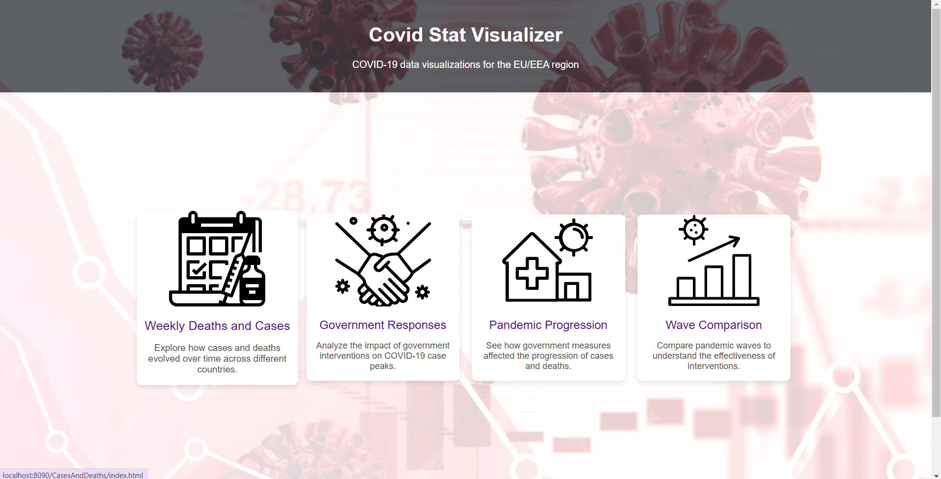

1. **Weekly Deaths and Cases by Country**

* **Purpose**:
  + Show the progression of cases and deaths.
  + Visualize the influence of vaccination rates on cases and deaths.
* **Features**:
  + Animations for line drawing.
  + Highlight of peak cases and deaths with markers and labels.
* **Elements**: Line charts for weekly cases and deaths; overlayed vaccination rates with an area fill.
  + Labels to indicate blue and red colors and their meanings.
  + Pandemic phases

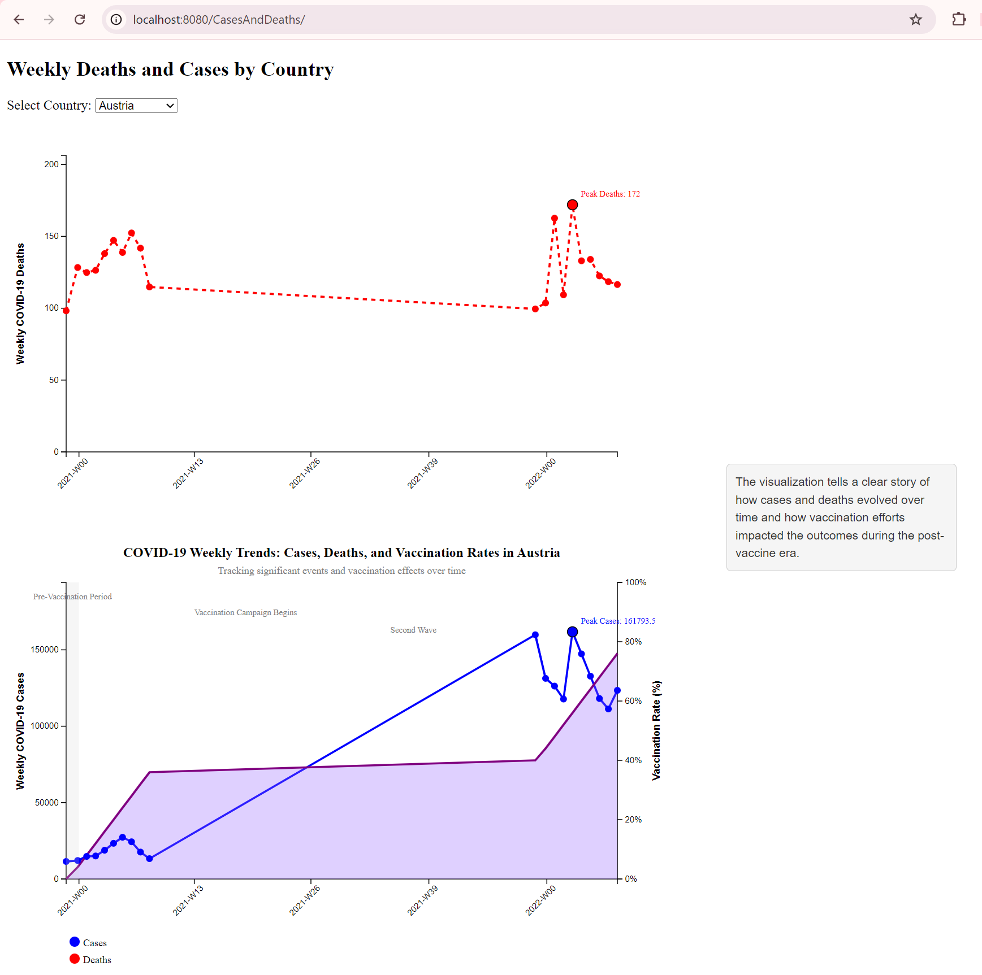

* **Interactions**:
  + Country selection through a dropdown menu.

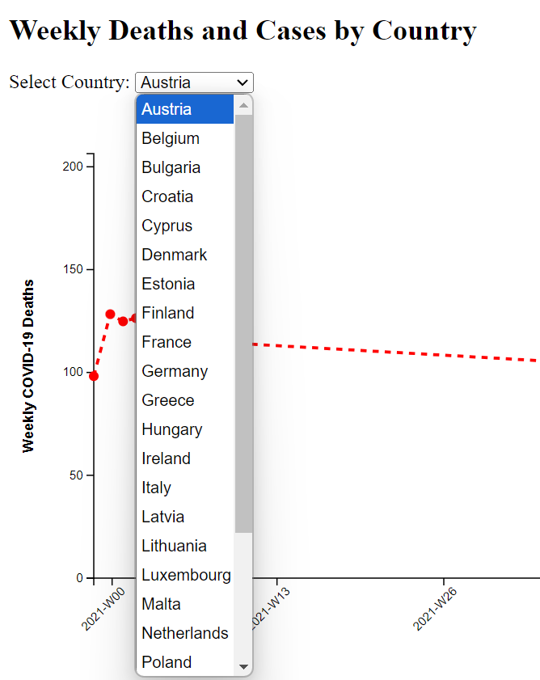

* + Tooltip displays detailed data points for cases, deaths, and vaccination rates.
* 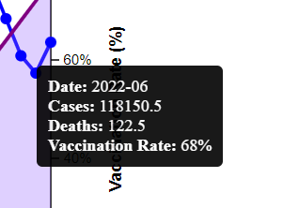
  + Highlights peaks, vaccination campaigns with annotations.
* 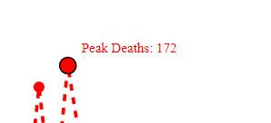
* 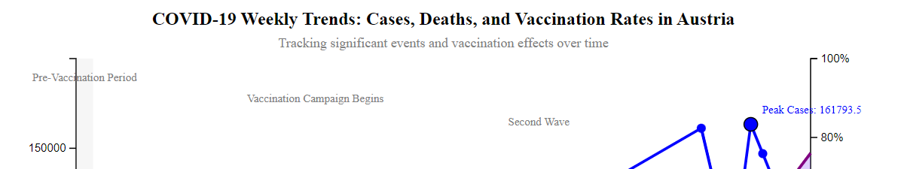

1. **Government Responses and COVID-19 Case Peaks**

* **Purpose**: Correlate intervention types and timing with changes in case trends.
* **Features**:
  + Color-coded markers for different intervention types.
  + Fade-in animations for intervention markers.
* **Elements**: Line chart showing weekly cases with intervention markers. The line chart is animated to show progression of cases over time.

The below screenshot does not show the animation and none of the intervention measures are selected.

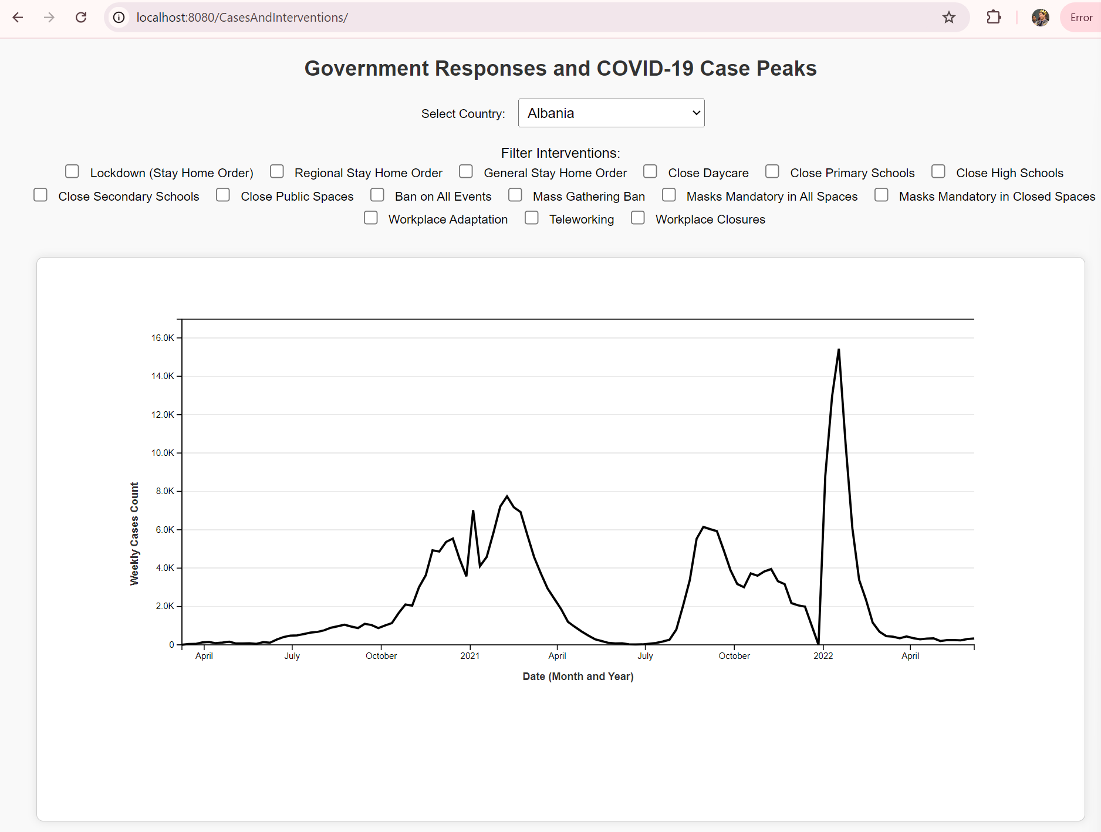

* **Interactions**: Filter interventions by type (e.g., lockdowns, mask mandates) using checkboxes.

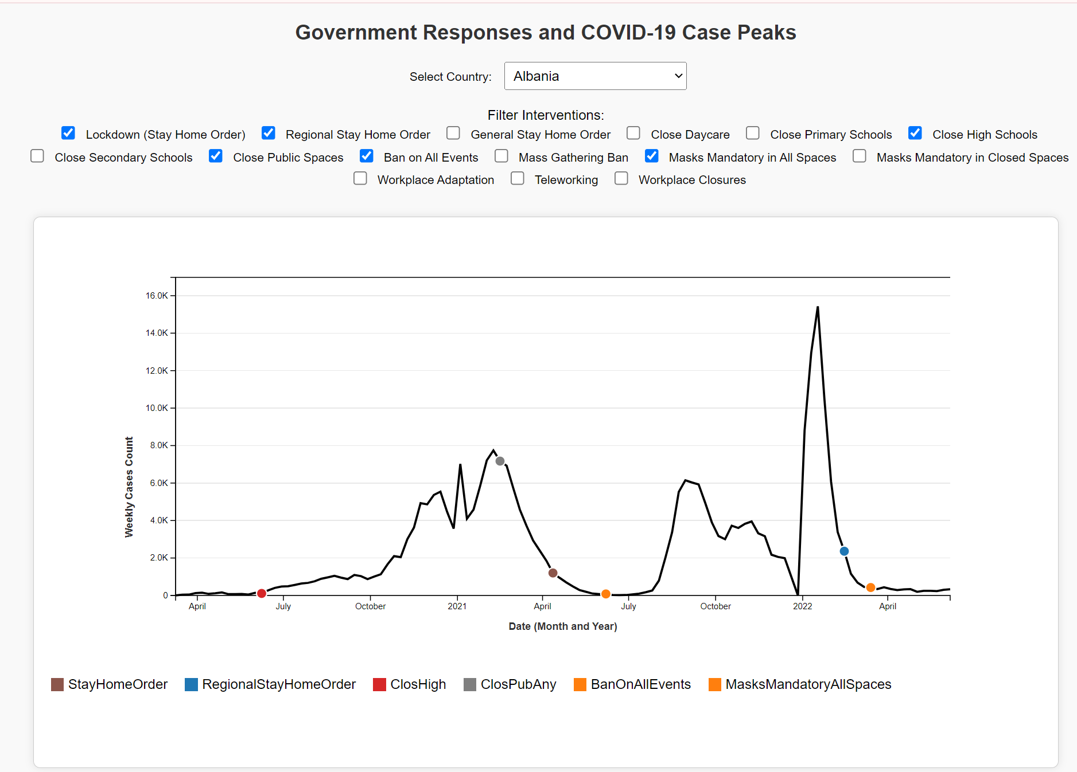

* Checking the boxes makes a dot appear on the line and multiple interventions can be selected at a time to see the effect of multiple things at a same time.
  + Country-specific data displayed based on dropdown selection.
  + Tooltip reveals intervention details on hover.
* Country-specific data displayed based on dropdown selection.

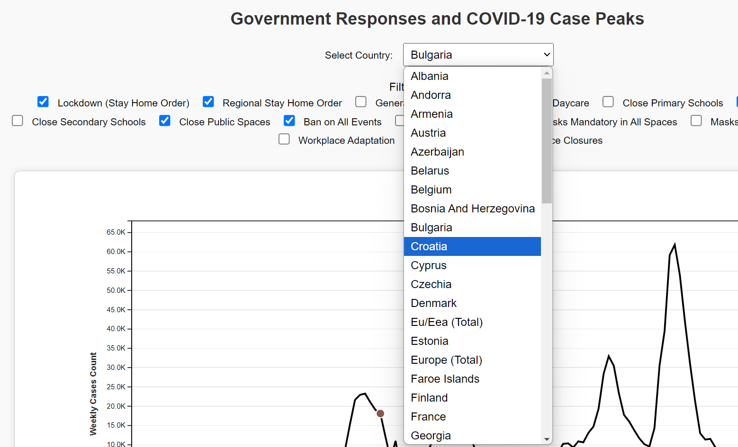

* Tooltip reveals intervention details on hover.

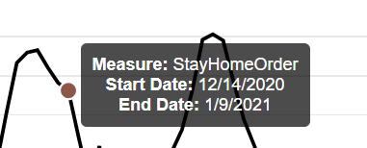

1. **Government Response Stringency Index vs. Cases and Deaths**

* **Purpose**: Evaluate the relationship between government responses and pandemic metrics.
* **Features**:
  + Animations for bar heights and line drawing.
  + Legends distinguish between cases, deaths, and stringency.
* **Elements**: Bar charts for normalized cases and deaths; overlayed line graph for stringency index.

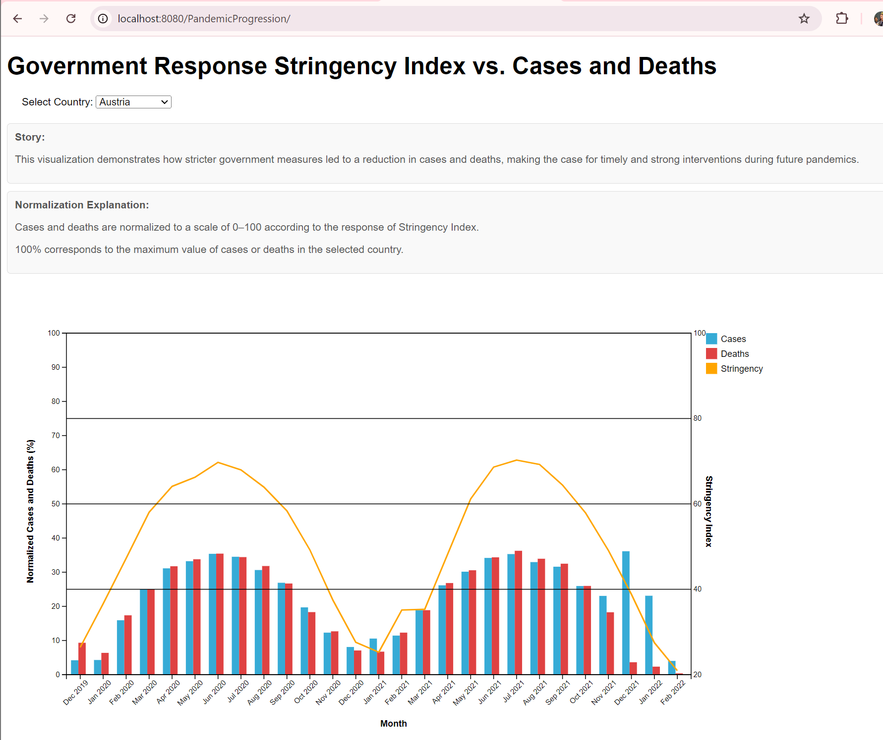

* Interactions:
  + Dropdown for selecting countries.
  + Tooltip for monthly details on cases, deaths, and stringency index.

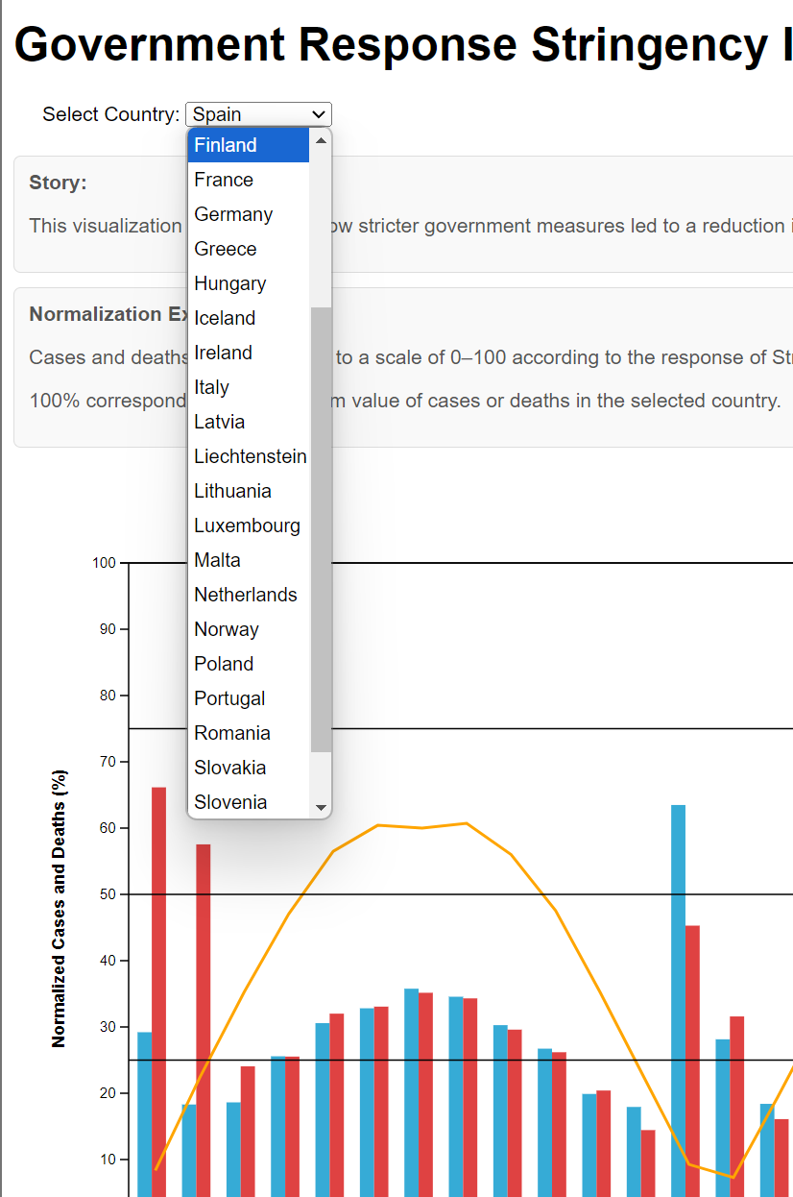 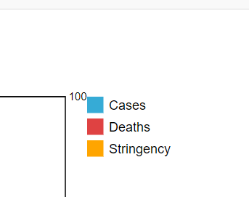

1. **Comparing Case Reductions Between Pandemic Waves**

* **Purpose**: Compare the effectiveness of interventions across waves and countries.
* **Features**:
  + Color gradient based on intervention stringency levels.
  + Side panel for expanded information on hover.
* **Elements**: Bar charts for case reductions grouped by pandemic waves (e.g., First Wave, Second Wave).
* **Features**:
  + Color gradient based on intervention stringency levels.
  + Side panel for expanded information on hover.
  + Country selection
  + Text describing details on stringency and bar graph details.

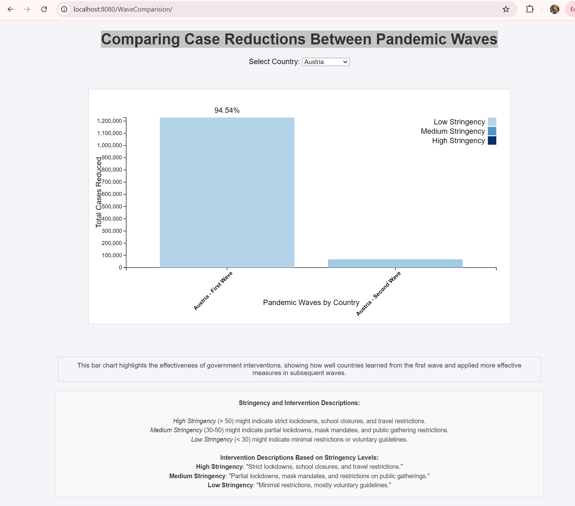

# 

**Landing page updated:**

We updated the landing page to include embedding of the screen cast video.

The video includes details about what visualization is for, how to navigate it in general, what are the interactive features are.

**EVALUATION:**

**1. What did you learn about the data by using your visualizations?**

* **Pandemic Trends:** The visualizations highlighted significant trends in COVID-19 cases and deaths across EU/EEA countries. For instance, peaks in case counts coincided with delays in vaccination rollouts or lapses in stringent government measures.
* **Vaccination Impact:** The correlation between increased vaccination rates and the reduction in case and death rates was clearly evident in the time-series and overlay charts. Countries with higher vaccination coverage experienced quicker case reductions during subsequent waves.
* **Government Interventions:** Different countries' stringency levels and timing of interventions, such as lockdowns or mask mandates, directly influenced the containment of cases. Countries with consistent, high-stringency measures saw less severe peaks compared to those with delayed or inconsistent measures.
* **Pandemic Waves:** Comparing pandemic waves revealed variations in the severity and response effectiveness. The data indicated that earlier waves were less effectively managed compared to post-vaccine phases.

**2. How did you answer your questions?**

* **Variation in Cases and Deaths Over Time:** Line charts of weekly cases and deaths provided clear visualizations of temporal trends, allowing users to track and compare changes over time.
* **Effect of Vaccination Campaigns:** The area and line charts with vaccination data overlays demonstrated a decline in cases and deaths post-vaccination. Annotations marking vaccine rollouts further clarified their impact.
* **Testing and Positivity Correlation:** Data preprocessing introduced rolling averages of positivity rates, enabling the exploration of testing effectiveness alongside case trends. However, this aspect could benefit from further refinement.
* **Effectiveness of Country Responses:** Bar charts comparing reductions in case counts across pandemic waves provided insights into the relative success of different nations' strategies. Stringency indexes overlayed with case trends highlighted the efficacy of strict interventions.
* **Pandemic Waves Comparison**: Grouped bar charts categorized by wave visually emphasized the differing impacts of interventions and pandemic characteristics across waves.

**3. How well does your visualization work?**

* **Interactive Exploration:** Dropdowns, filters, and tooltips enriched the user experience, enabling customized analysis of countries and timeframes.
* **Clarity in Trends:** The line and bar charts effectively showcased trends, peaks, and patterns in the data.
* **Focus on Comparisons:** Comparative visualizations between countries and waves made it easy to derive meaningful insights.
* **Animations:** Smooth animations enhanced understanding by dynamically guiding users through the data progression.

**4. How Could You Further Improve It?**

* Usability: Simplify filters and add a guided walkthrough.
* Data: Include scatter plots for correlations and cumulative metrics for context.
* Performance: Use data aggregation and lazy loading for faster rendering.
* Accessibility: Add dark mode, improve contrast, and support screen readers.
* Advanced Features: Implement predictive analytics and allow saving custom views.